E- School

A School Management System

Muhammad Sa’ad Naasik: 1005092

Md. Tamzeed Islam: 1005094

Bashima Islam: 1005095

Md. Shamim Hasnath: 1005096

Akib Ibn Zahid: 1005098

# Table of Content

* Subsystem wise **Data Flow Diagram** & **Fishbone Diagram**
* Feasibility Studies
  + Operational
  + Cultural
  + Technical
  + Economics
* Tangible and Intangible Benefits

## Subsystems:

1. User Profile Subsystem

2. Student Profile Subsystem

3. Course Work Subsystem

4. Examination Subsystem

5. Result Subsystem

6. Notice Subsystem

## Dataflow Diagram of User Profile Subsystem

Figure 1 : Dataflow Diagram of User Profile Subsystem

## Dataflow Diagram of Student Profile Subsystem

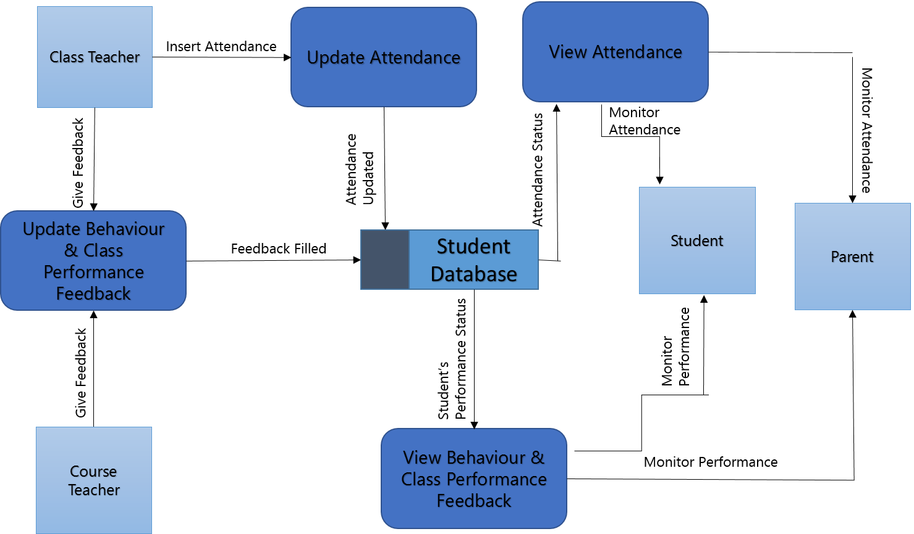

Figure 2: Dataflow Diagram of Student Profile Subsystem

## Dataflow Diagram of Course Work Subsystem

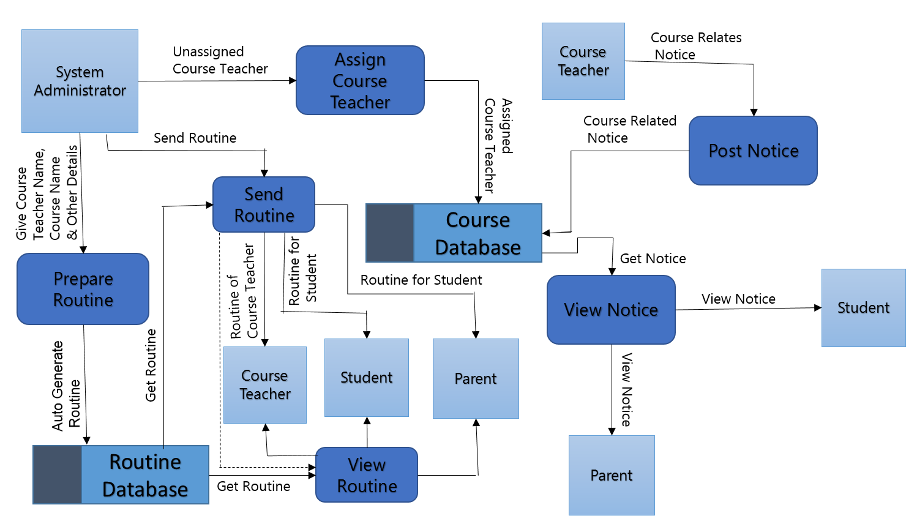

Figure 3: Dataflow Diagram of Course Work Subsystem

## Dataflow Diagram of Examination Subsystem

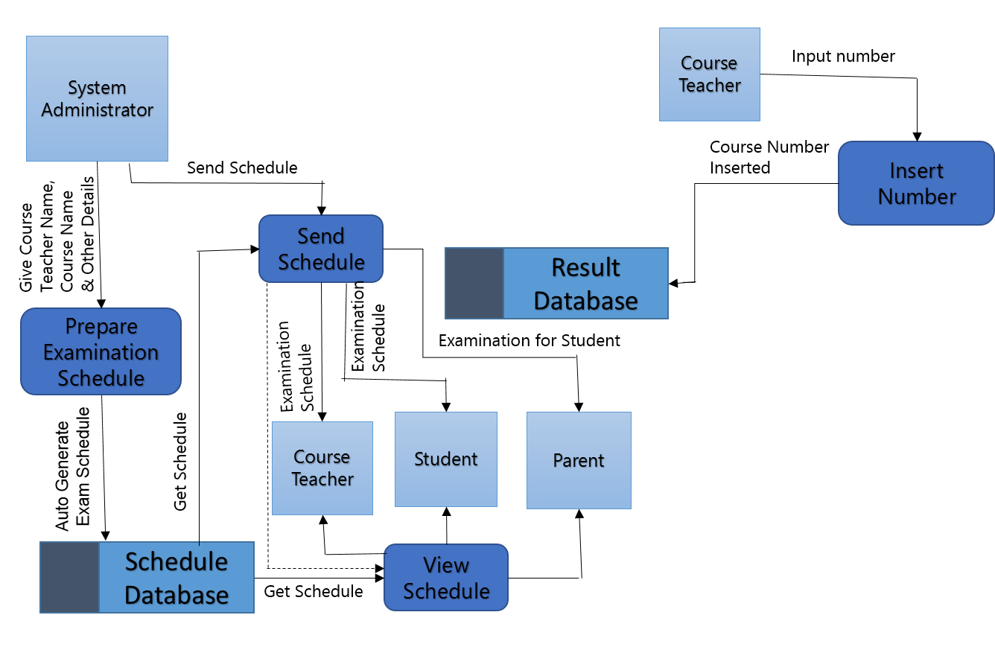

Figure 4: Dataflow Diagram of Examination Subsystem

## Dataflow Diagram of Result Subsystem

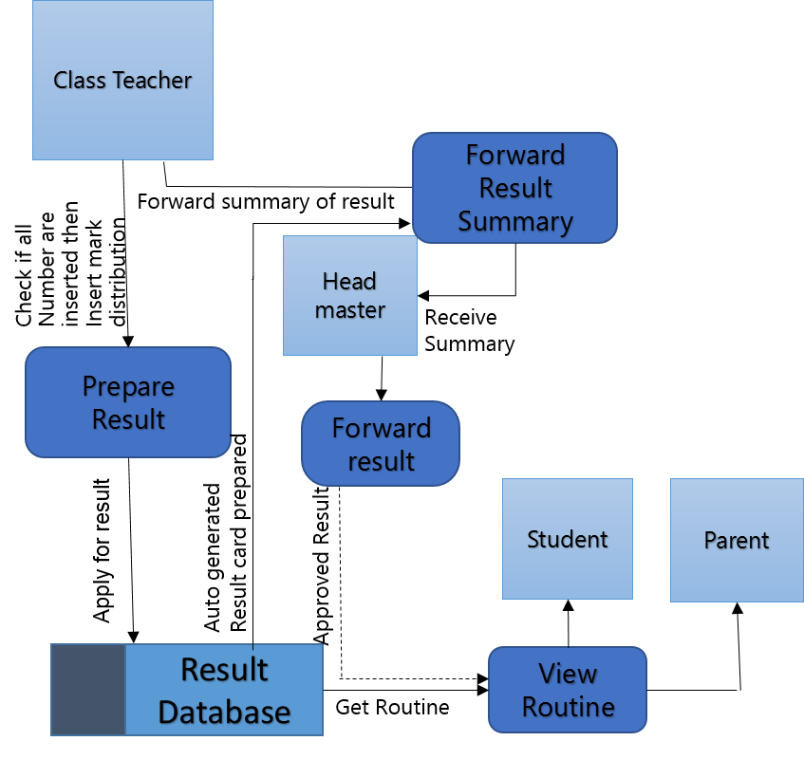

Figure 5: Dataflow Diagram of Result Subsystem

## Dataflow Diagram of Notice Subsystem

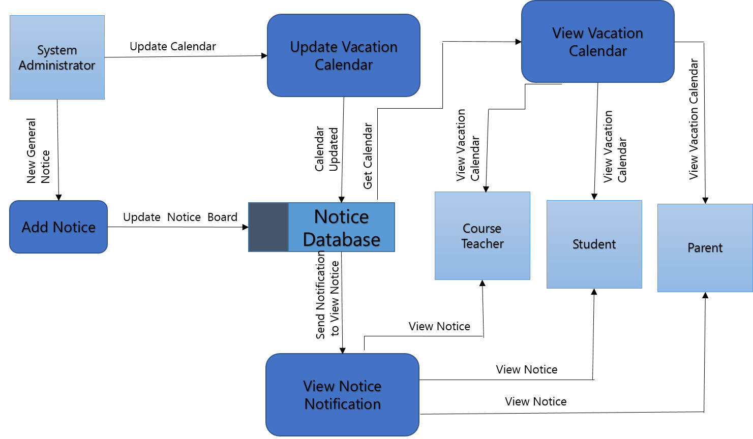

Figure 6: Dataflow Diagram of Notice Subsystem

## Fishbone Diagram of User Profile Subsystem

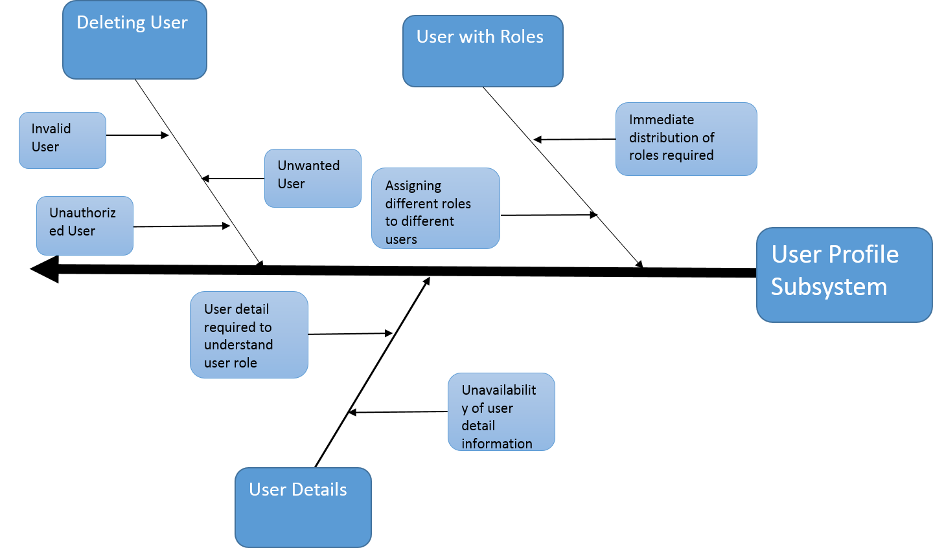

Figure 7: Fishbone Diagram of User Profile Subsystem

## Fishbone Diagram of Student Profile Subsystem

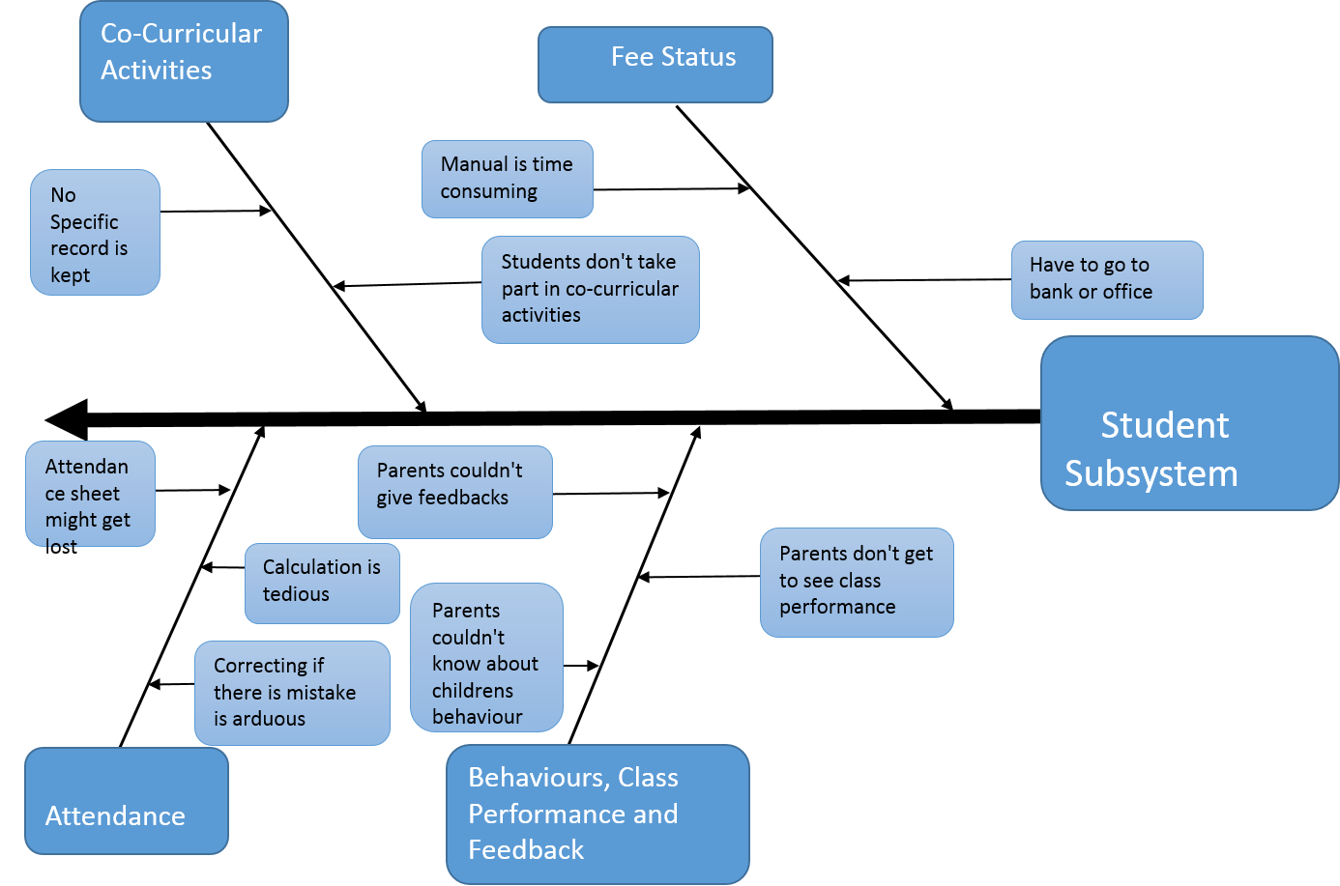

Figure 8: Fishbone Diagram of Student Profile Subsystem

## Fishbone Diagram of Course Work Subsystem

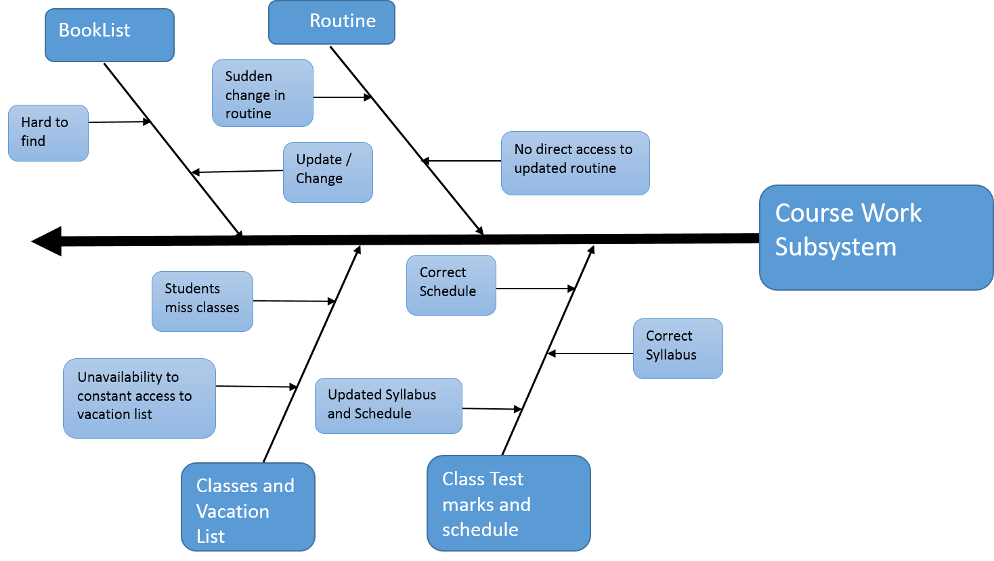

Figure 9: Fishbone Diagram of Course Work Subsystem

## Fishbone Diagram of Examination Subsystem

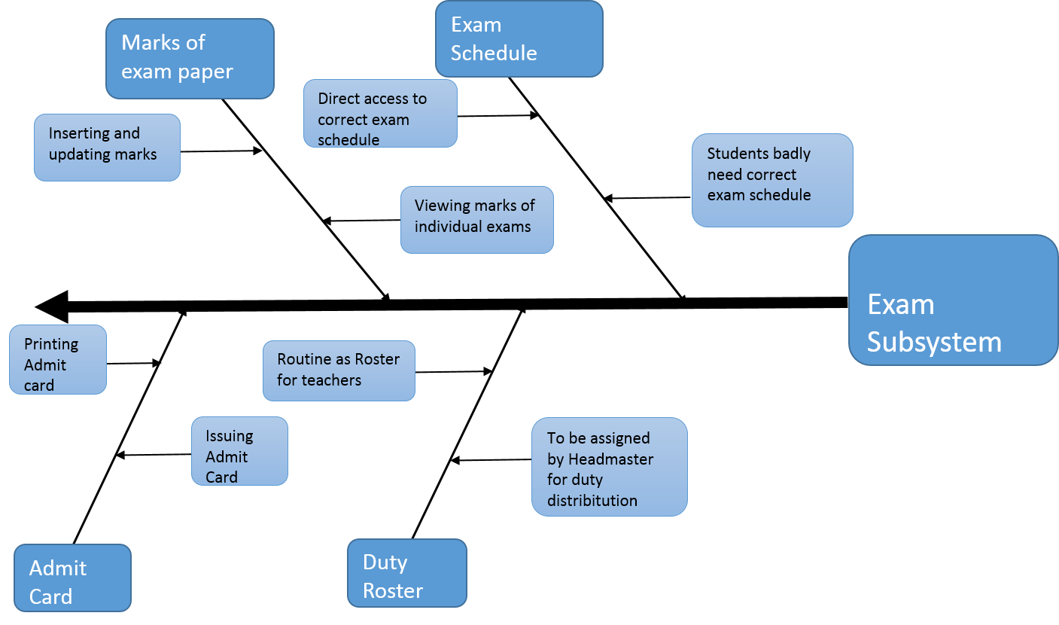

Figure 10: Fishbone Diagram of Examination Subsystem

## Fishbone Diagram of Result Subsystem

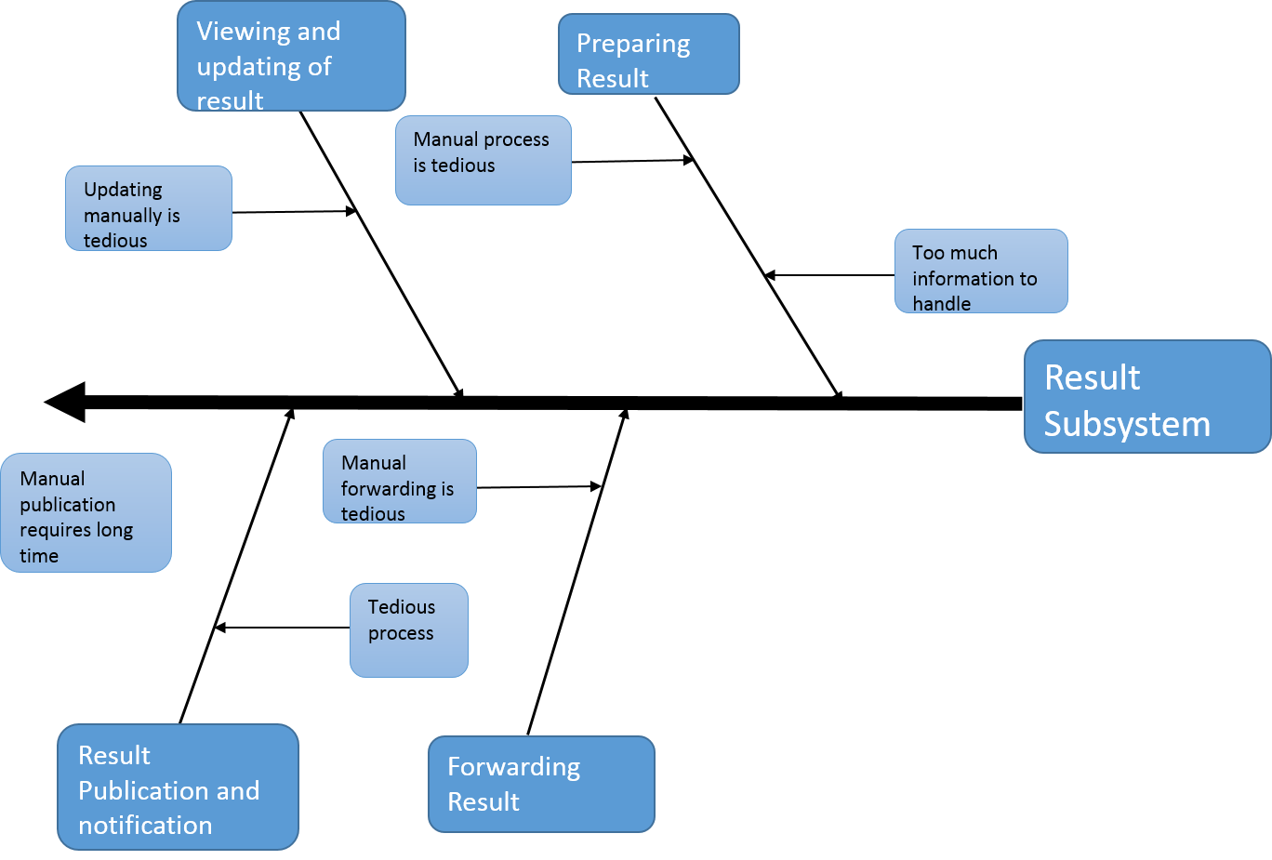

Figure 11: Fishbone Diagram of Result Subsystem

## Fishbone Diagram of Notice Subsystem

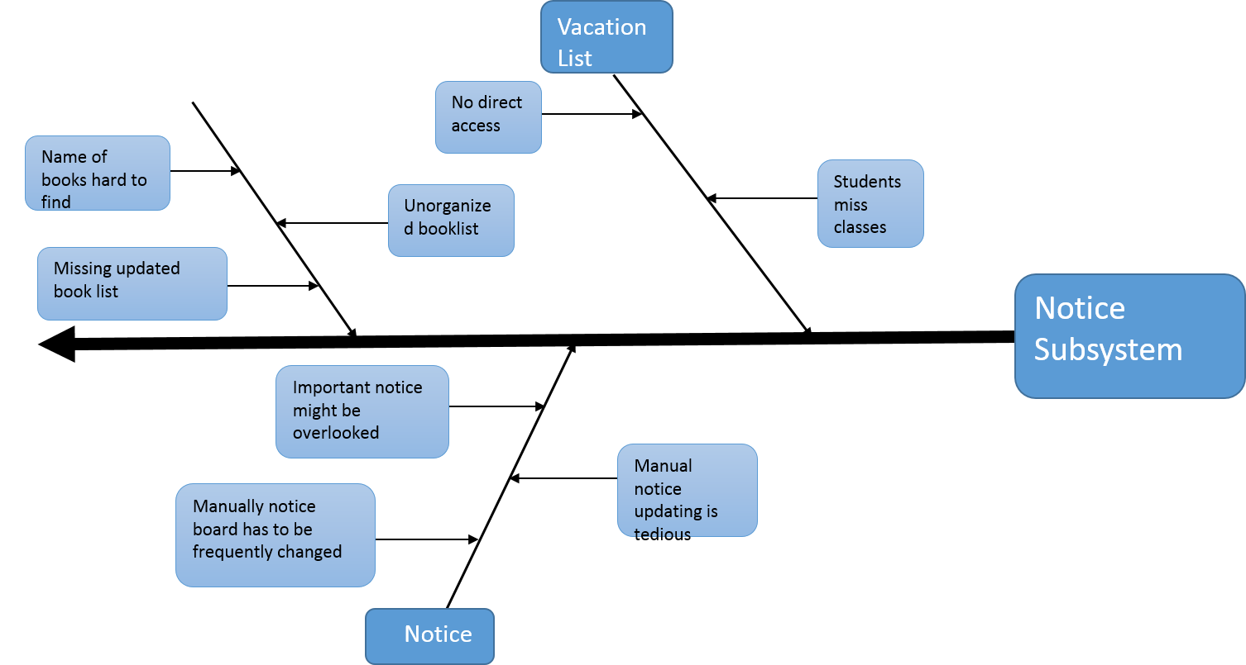

Figure 12: Fishbone Diagram of Notice Subsystem

Operational Feasibility:

Our proposed system meets the challenge of transforming the manual school management system into an automated process. Most of the schools in our country are manually organized. As a result students, teachers and parents of the students face numerous problems. The main objective of this system is to mitigate these problems faced by these communities.

### Benefits students will get:

1. During our requirement analysis phase we came to know that most of the students don’t have easy access to their class routine, syllabus and schedule of exam. With our system students can easily get their class routine and exam schedule from their profile.
2. In a developing country like ours where political situation is never stable, sudden change in the routine of exam and closure of school occur. But for now, most of the students fail to get those sudden notice with the current systems. On the other hand, our system provides a notice board subsystem where students, teachers and parents can get these sudden notices whenever they are available.
3. With our system students will be able to get their marks and recommendations (if there any) and remarks from teachers directly through their profile.

### Benefits Teachers will get:

1. One of the hardest tasks of teachers is to prepare mark sheets and calculate result manually. To address this problem our system provides the teachers a sub system for making results with ease and also forward and approve the result when it is necessary.
2. There is a gap between teacher and parent community in the prevailing systems. To make a connection bridge between these two vital communities our system provides a notice system via which they can communicate with one another.
3. Also our system allows the teachers to make them able to view their routine and duty roaster when they need.

### Benefits Parents will get:

1. With the existing systems parents fail to gather correct information about their children in many aspects. But our system provides the parents with the facility to get the correct informations about their children.
2. Our system provides a better way to get notified about upcoming meetings or ceremonies.
3. Parents will get direct access to tuition fee status of their children via their profile.

So in a nutshell after studying or requirement analysis along with the scope definition of our project, it can be stated that the proposed features of our system will be beneficial and practical in any school management system.

## Cultural Feasibility:

In the previous section the operational feasibility of our system has been discussed based on how well our system meets the requirement analysis and scope definition. In this section we will focus more on the behavioral aspect of the end users who will use our system.

1. Our system provides a secured registration process and the log in system is well secured to maintain the privacy of the school administration and teachers. So teachers and headmaster don’t need to worry about any security issue.
2. In our requirement analysis we found that most of the students have urge to get easy and regular access to their syllabus and schedule of exams. In our system students will be able to get these very easily which will make them more efficient in their academic purposes.
3. Our system will provide a simple and fluid user interface along with user experience to make all the users as much comfortable as they can feel.
4. From requirement analysis we found from the management administrator of schools that they are eager to make this system integrated with their existing management system.
5. In our system we try our best not to change the elements of the existing systems. Rather we have lessened the manual work of teachers, students and parents. So the users including the aged persons will easily be adapted with the system.
6. There may be some resisting on the part of the new users at the very first time to use this new system. But as our system is fairly interactive and easy to use it won’t take long for the users to get accustomed with this system.

## Technical Analysis:

* We are going to use following technologies to implement our system:
  + JSP/Servlet (Java EE) for server side.
  + MySQL for database system.
  + TomEE (Apache Tomcat) as application server.
* E-School doesn’t require anything special apart from those are currently available.
* Internet is widely available now-a-days in the country with the blessing of 3G mobile network.

## Economic Analysis:

Revenue during the first year:

Table 1: Revenue During 1st Year

|  |  |  |
| --- | --- | --- |
| **No.** | **Name** | **Cost** |
| **1** | Software development | 350,000 BDT |
| **2** | Web Server | 50,000 BDT/year |
| **3** | Maintenance | 30, 000 BDT/year |
|  | Total | 430,000 BDT |

Developer’s Cost:

Table 2: Developer's Cost

|  |  |  |
| --- | --- | --- |
| **No.** | **Name** | **Cost** |
| **1.** | Web server | 50,000 BDT/year |

Profit during the first year:

4, 30, 000 – 50,000 BDT = 380,000 BDT

## Tangibility Analysis:

1. Save time.
2. Reduce paper work
3. No registration process needed.
4. Decrease response time.

## Intangibility Analysis:

1. Automation of result.
2. Tracking of student’s attendance.
3. Better monitoring system.
4. Easy access to children’s profiles for parents.